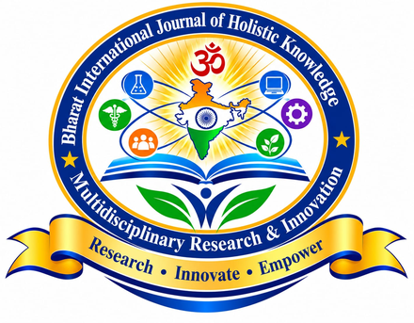
Bharat International Journal of Holistic Knowledge, Multidisciplinary Research & Innovation
Research • Innovate • Empower
COPYRIGHT TRANSFER AND UNDERTAKING FORM
Manuscript / Paper ID
Title of the Paper
Name(s) of All Authors
Corresponding Author
Email and Mobile
Address for Communication

We, the undersigned authors, hereby declare and agree that:
1. The paper is our original work. It has not been published before and is not under consideration for publication anywhere else.
2. The paper does not infringe any copyright or other rights of any person, and all sources used have been properly cited.
3. All authors have contributed to the work, have read and approved the final version, and agree to its publication.
4. Any research involving human participants or animals was carried out with the required ethical approval and consent.
5. We keep the copyright of the paper and grant the journal the right to publish it first, and to reproduce and distribute it in print and electronic form under the Creative Commons Attribution 4.0 (CC BY 4.0) licence.
6. If plagiarism, data fabrication or any other misconduct is found, the journal may withdraw or retract the paper, and the authors alone will be responsible.
7. The views expressed in the paper are those of the authors and not of the journal, its board or the publisher.

Author Name | Signature | Date

Please sign, scan and email this form with your payment details to bharatijhk@gmail.com, mentioning your Paper ID in the subject line.

